#### HANDS Workshop

**HANDS WORKSHOP: Geometry Design principles and its application on crafts**

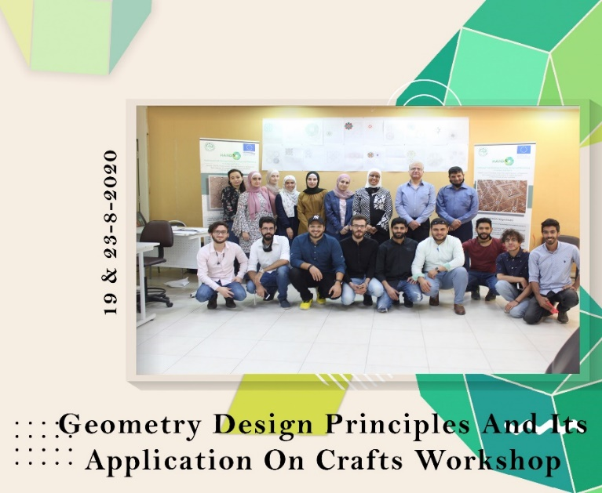**WP 5: DEVELOPMENT**

**Date:** Wednesday, Thursday, 19-20/8/2020  
**Organizer:** Craft society initiative/ Al-Zaytoonah University of Jordan  
**Location:** Department of Architecture / Faculty of Architecture and Design (ZUJ)

A two-day HANDS workshop focused on the basics of Islamic geometry and its relevance to crafts. Miss Hana Hijazi, a specialist in the field, led the sessions. Participants learned about the hexagonal pattern and its connection to various shapes, the dodecahedron, and the square shape, exploring their applications in cultural and artistic contexts. This workshop provided practical insights into geometric design principles and their relevance to various crafts.